
BAHRIA UNIVERSITY, ISLAMABAD
Department of Computer Science

DESIGN AND ANALYSIS OF ALGORITHMS
Assignment # 03

Submitted To: Saima Jawad

Umm-e-Habiba Imran
01-134241-048

Table of Contents
1 Problem: 128. Security Switches 3
2 Objective 4
3 Techniques Used 4
4 Brute Force 4
4.1 Sub Functions 5
4.2 Pseudocode 5
4.3 Complexity Analaysis 7
4.4 Space Complexity 9
5 Divide and Conquer 10
5.1 Recursive Strategy 10
5.2 Pseudocode 11
5.3 Complexity Analysis 11
5.4 Space Complexity 13
6 Comparison (Brute Force vs Divide and Conquer) 14
7 Conclusion 15
8 References 15
9 Acknowledgement of the Implementation 15

1 Problem: 128. Security Switches
There is a row of n security switches protecting a military installation entrance. The switches can be manipulated as follows:
- The rightmost switch may be turned on or off at will.
- Any other switch may be turned on or off only if the switch to its immediate right is on and all the other switches to its right, if any, are off.
- Only one switch may be toggled at a time.
Devise an algorithm to turn off all the switches, which are initially all on, in the minimum number of moves. (Toggling one switch is considered one move.) Find the minimum number of moves.
Initial State: 111...1 (n switches ON)
Goal State: 000...0 (all switches OFF)
- Switch n (rightmost): can always be toggled freely
- Switch i (i < n): can be toggled only if switch i+1 is ON AND all switches i+2 ... n are OFF

Objective
- To design an algorithm that transforms the initial configuration of switches (all ON) into the target configuration (all OFF).
- To ensure that all switch operations strictly follow the given constraints for valid moves.
- To determine the minimum number of moves required to turn off all switches.
- To explore all possible valid states in a systematic manner in order to guarantee an optimal solution.
- To avoid revisiting previously explored states by maintaining appropriate data structures.
- To implement and analyze the problem using suitable algorithm design techniques (such as Breadth-First Search and Recursive approach).
- To evaluate the efficiency of the algorithms in terms of time and space complexity.

Techniques Used
1. Brute Force (Breadth-First Search - BFS)
- Explore all valid configurations (states)
- Use BFS to guarantee minimum number of moves
2. Divide-and-Conquer
- Reduce the problem recursively using constraints
- Use recurrence: $M(n)=M(n-1)+2M(n-2)+1$

Brute Force
The brute force technique is applied by exploring all possible valid states starting from the initial configuration 111...1 to reach the goal state 000...0. Breadth-First Search (BFS) is used to systematically explore the state space level by level, guaranteeing that the first time the goal state is reached corresponds to the minimum number of moves.

Sub Functions
IsValidMove(state, i): Returns true if switch i can be toggled given current state.
- Rightmost switch (i = n-1): always valid
- All other switches: valid only if state[i+1] = 1 AND state[i+2 ... n-1] are all 0
ToggleSwitch(state, i): Returns a new state with switch i flipped. Does NOT modify original state.
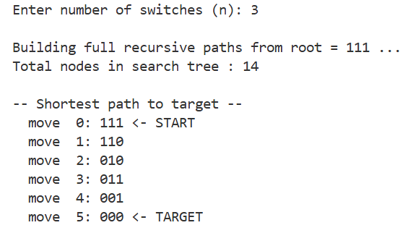

Pseudocode
Algorithm BFS_SwitchProblem(n)
// Input: n = number of switches
// Output: Minimum number of moves to turn all switches OFF

initial_state ← [1, 1, 1, ..., 1] // n switches all ON
goal_state ← [0, 0, 0, ..., 0] // n switches all OFF

if initial_state = goal_state then
return 0
queue ← empty FIFO queue
visited ← {}
Enqueue(queue, (initial_state, 0)) // (state, move_count)
Add initial_state to visited
while queue is not empty do
(current_state, moves) ← Dequeue(queue)
for i ← 0 to n-1 do // Try toggling each switch
if IsValidMove(current_state, i) then
new_state ← ToggleSwitch(current_state, i)
if new_state = goal_state then
return moves + 1 // Minimum moves found
if new_state ∉ visited then
Add new_state to visited
Enqueue(queue, (new_state, moves + 1))
return -1 // No solution found (should never happen)

─────────────────────────────────────────────────────────────

Function IsValidMove(state, i)
// Returns true if switch at position i can be toggled
if i = n-1 then // Rightmost switch
return true
if state[i+1] ≠ 1 then // Switch to right must be ON
return false
for j ← i+2 to n-1 do // All switches further right
if state[j] ≠ 0 then
return false
return true

─────────────────────────────────────────────────────────────

Function ToggleSwitch(state, i)
// Returns new state with switch i flipped
new_state ← copy of state // O(n) copy operation
new_state[i] ← 1 - new_state[i] // Flip: 0→1 or 1→0
return new_state

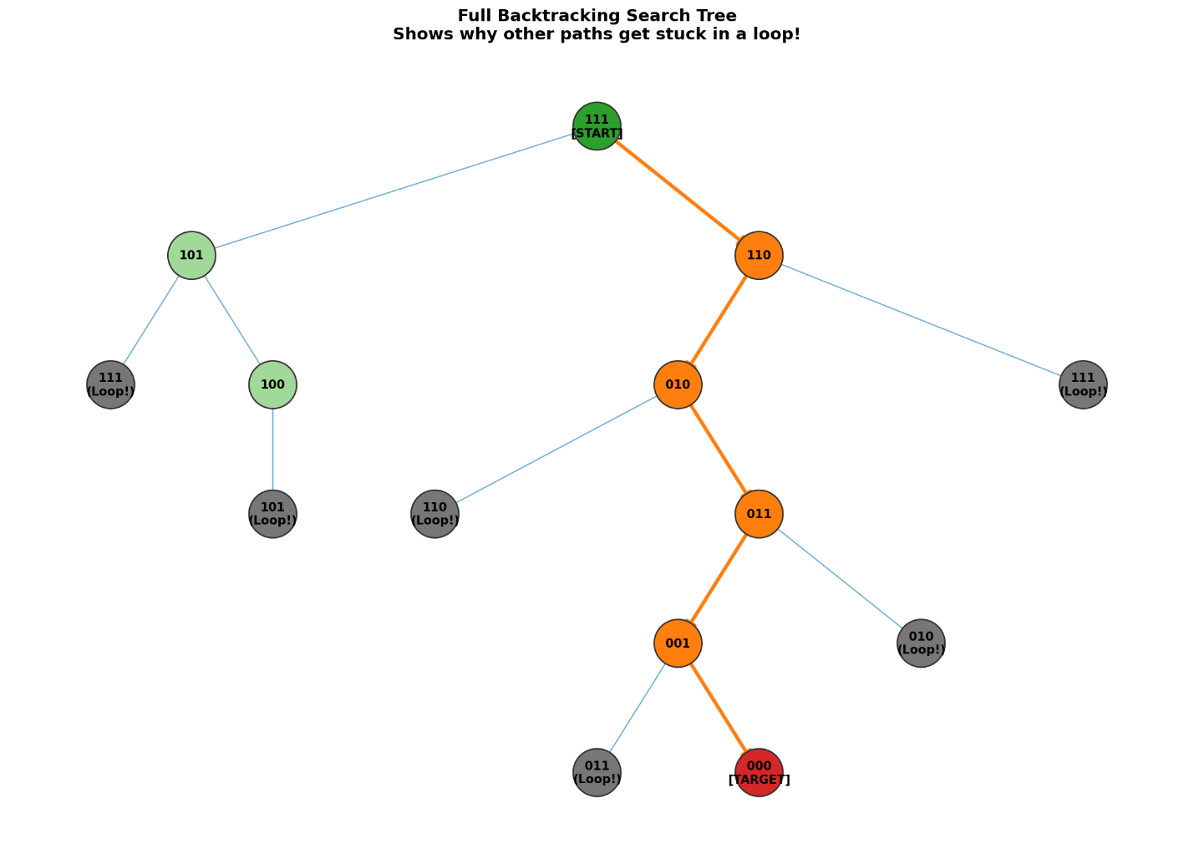

Complexity Analaysis
Total Number of States
Each switch has 2 possible values (ON/OFF). For n switches:
$$Total States = 2ⁿ$$
In the worst case, BFS explores all reachable states before finding the goal.
Cost per State — IsValidMove(state, i)
Constant overhead: O(1) per call for boundary checks
Inner loop (checking switches j = i+2 to n-1):
$$\sum_{k=0}^{n-1}{1} = n - i - 2$$

Cost per State — ToggleSwitch(state, i)
$$Array copy cost = O(n)$$
Total cost per single state
$$T_{state}=\sum_{i=0}^{n-1}{\left[\left(n-i-2\right)+ n\right]}=\sum_{i=0}^{n-1}{(2n-i-2)}$$
Splitting and simplifying the summation:
$$= Σ(2n-2) - Σi = n·(2n-2) - n·(n-1)/2$$
$$= 2n^{2}-2n -\frac{n^{2}-n}{2}= \frac{4n^{2}-4n-n^{2}+n}{2}= \frac{3n^{2}-3n}{2}$$
$$T_state = (3/2) · n · (n-1)$$
Total BFS Complexity over all 2ⁿ States
$$T(n) = 2ⁿ · (\frac{3}{2}) · n · (n-1) = (\frac{3}{2}) · n(n-1) · 2ⁿ$$
Asymptotic Verification
$$f(n) = (\frac{3}{2})(n²-n)·2ⁿ and g(n) = n²·2ⁿ$$
$$c₁·(n²·2ⁿ) ≤ (\frac{3}{2})(n²-n)·2ⁿ ≤ c₂·(n²·2ⁿ)$$
$$c_{1}=\frac{3}{4} and c_{2}=\frac{3}{2} for n ≥ 2:$$
$$(\frac{3}{4})·n²·2ⁿ ≤ (\frac{3}{2})·n²·2ⁿ - (\frac{3}{2})·n·2ⁿ ≤ (\frac{3}{2} )·n²·2ⁿ$$
Upper Bound:
$$f(n) = O(n²·2ⁿ)$$
Lower Bound:
f(n) = Ω (n²·2ⁿ$)$
Tight Bound:
$$f(n) = Θ(n²·2ⁿ)$$
$$T(n) = Θ(n²·2ⁿ)$$
Best Case vs Worst Case
Worst Case: BFS explores all 2ⁿ states before finding goal → T(n) = Θ(n²·2ⁿ)
Best Case: Goal state found immediately (trivial for n=0). For non-trivial input (n≥1) with all switches ON, BFS must traverse M(n) = Θ(2ⁿ) levels minimum → T(n) = Ω(2ⁿ)
Minimum Number of Moves
BFS guarantees optimality — the first path found is always the shortest. From the recurrence:
$$M(n) = M(n-1) + 2·M(n-2) + 1$$
Even n:
$$M\left(n\right)=\frac{\left(2^{n+1} - 2\right)}{3}$$
Odd n:
$$M\left(n\right)=\frac{2^{n+1} - 1}{3}$$
Minimum Moves:
$$M(n)=Θ(2^{n})$$

Space Complexity
BFS stores every state it visits in the queue and visited set.
- Total states in the worst case: 2ⁿ
- Each state is stored as an array/string of size n
- Queue and visited set both can grow to 2ⁿ entries simultaneously
$$Space Complexity = O(n · 2ⁿ)$$

Divide and Conquer
Instead of exploring all possible configurations, this approach solves the problem recursively by reducing it into smaller subproblems, guided by the structural constraints of valid switch operations.
Key Insight: To turn OFF switch 1 (leftmost), the system must first reach the state:
1100...0 (Switch 2 ON, switches 3..n all OFF)
This forces a recursive decomposition into subproblems of size (n-2) and (n-1).

Recursive Strategy
To solve the problem for (n) switches (initially all ON):

Step 1: Turn OFF the last (n-2) switches
1111...1 → 1100...0
Cost: M(n-2)

Step 2: Toggle switch 1 (now valid since switch 2 is ON and switches 3..n are OFF)
1100...0 → 0100...0
Cost: +1

Step 3: Restore the last (n-2) switches back to ON
0100...0 → 0111...1
Cost: +M(n-2)

Step 4: Solve the remaining (n-1) switches recursively
0 | 111...1 → 0 | 000...0
Cost: +M(n-1)

Final Recurrence Relation
Combining all steps:
$$M(n) = M(n-2) + 1 + M(n-2) + M(n-1)$$
$$M(n) = M(n-1) + 2·M(n-2) + 1 for n ≥ 3, M(1) = 1, M(2) = 2$$

Pseudocode
Algorithm DivideConquerSwitches(n)
// Input: n = number of switches (all initially ON = 1)
// Output: Minimum number of moves to reach 000...0

if n = 1 then
toggle switch 1 // Only switch: turn it OFF
return 1 // Base case: 1 move

if n = 2 then
toggle switch 2 // Turn OFF rightmost
toggle switch 1 // Switch 2 OFF, switch 1 can be toggled
return 2 // Base case: 2 moves

// Step 1: Turn OFF last (n-2) switches [Cost: M(n-2)]
moves ← DivideConquerSwitches(n-2)

// Step 2: Toggle switch 1 [Cost: +1]
toggle switch 1
moves ← moves + 1

// Step 3: Restore last (n-2) switches back to ON [Cost: +M(n-2)]
moves ← moves + DivideConquerSwitches(n-2)

// Step 4: Solve remaining (n-1) switches recursively [Cost: +M(n-1)]
moves ← moves + DivideConquerSwitches(n-1)

return moves

Complexity Analysis
Recurrence:
$$M(n) = M(n-1) + 2·M(n-2) + 1$$
Expansion — Step 1: Substitute M(n-1)
$$M(n-1) = M(n-2) + 2·M(n-3) + 1$$
Substitute into M(n):
$$M\left(n\right)=\left[M\left(n-2\right)+2M\left(n-3\right)+1\right]+2M\left(n-2\right)+1=3M\left(n-2\right)+2M\left(n-3\right)+2$$
Expansion — Step 2: Substitute M(n-2)
$$M\left(N-2\right)=M\left(n-3\right)+2M\left(n-4\right)+1$$
Substitute:
$$M\left(n\right)=3\left[M\left(n-3\right)+2M\left(n-4\right)+1\right]+2M\left(n-3\right)+2=5M\left(n-3\right)+6M\left(n-4\right)+5$$
General Pattern after k expansions
$$M\left(n\right)=a_{k}M\left(n-k\right)+b_{k}M\left(N-k-1\right)+c_{k}$$
The dominant coefficient follows the recurrence of Fibonacci-like growth, leading to:
$$M\left(n\right)≈2M\left(n-1\right) (dominant term)$$
Closed-Form Solution (from Book)
$$M\left(n\right)=\left(\frac{2}{3}\right)2^{n}-\left(\frac{1}{6}\right){\left(-1\right)}^{n}-\frac{1}{2}$$
Even n
$$M\left(n\right)=\frac{2^{n+1}-2}{3}$$
Odd n
$$M\left(n\right)=\frac{2^{n+1}-1}{3}$$
Asymptotic Bounds
Upper Bound:
$$M\left(n\right)≤M\left(n-1\right)+2M\left(n-1\right)+1=3M\left(n-1\right)+1$$
$$M\left(n\right)=O\left(2^{n}\right)$$
Lower Bound:
$$M(n) ≥ 2·M(n-2)$$
$$M(n) = Ω(2ⁿ)$$
Tight Bound: Since M(n) grows as
($\frac{2}{3})·2ⁿ →M\left(n\right)=Θ(2ⁿ)$
$$T(n) = Θ(2ⁿ) [Worst Case = Best Case = Only Case]$$
There is only one case for this algorithm — the algorithm always follows exactly the same recursive structure regardless of input, since the initial state is always all-ON and the goal is always all-OFF.
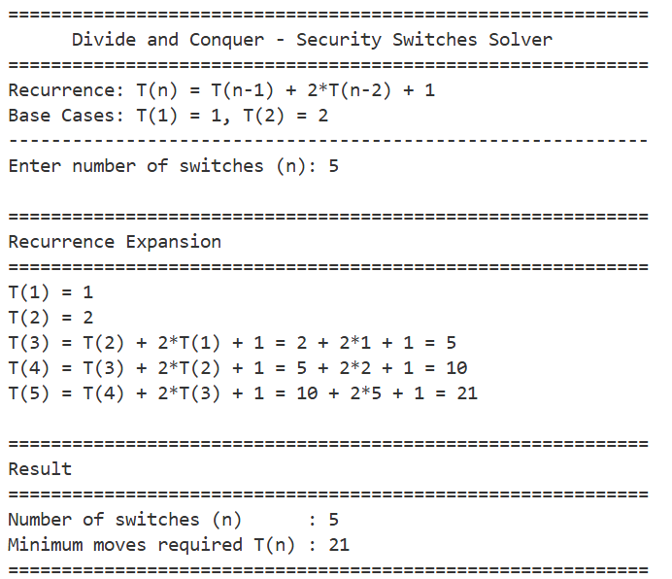

Space Complexity
The algorithm is recursive. Space usage depends on the maximum recursion depth.
Recursion chain: $n → n-1 → n-2 → ... → 1$
Maximum depth: n levels (each call reduces by at least 1)
$Space Complexity = O(n$)

Comparison (Brute Force vs Divide and Conquer)

Criterion | Algorithm 2: Brute Force (BFS) | Algorithm 1: Divide & Conquer
Design Technique | Brute Force (BFS State-Space Search) | Divide and Conquer (Recursive Decomposition)
Approach | Explore all valid states level-by-level until goal is reached | Exploit constraint structure to directly compute solution path
Worst Case | Θ(n²·2ⁿ) | Θ(2ⁿ)
Best Case | Ω(2ⁿ) [when goal found early] | Θ(2ⁿ) [same as worst]
Upper Bound | O(n²·2ⁿ) | $$O(2ⁿ)$$
Lower Bound | $$Ω(n²·2ⁿ)$$ | $$Ω(2ⁿ)$$
Time Tight Bound | $$Θ(n²·2ⁿ)$$ | $$Θ(2ⁿ)$$
Space Complexity | O(n·2ⁿ) [queue + visited set] | O(n) [recursion stack depth]
Optimality | Always optimal — BFS guarantees shortest path | Always optimal — directly computes minimum moves
Correctness Guarantee | Guaranteed by BFS level-order exploration property | Proven by induction on recurrence structure
Number of Cases | Best, average, and worst cases differ | Only one case (deterministic structure)
Data Structures | FIFO queue + hash set (visited states) | Call stack (implicit recursion)
Scalability | Less scalable — space is $O(n·2ⁿ),$ memory-intensive | More scalable — space is only O(n)
Knowledge Required | No domain knowledge needed — generic state exploration | Problem insight needed to identify recursive structure
Implementation Complexity | More complex — requires queue, visited set, state encoding | Simpler — short recursive function
Closed-form Solution | Confirmed by BFS, not derived analytically | Yes: M(n) = $(2/3)·2ⁿ - (1/6)·(-1)ⁿ - 1/2$
Practical Advantage | Useful for general puzzles; verifies the optimal solution | Efficient both in time and memory for large n

Conclusion
Overall, both approaches confirm that the problem has exponential time complexity, but they differ in methodology: BFS is suitable for explicit state-space exploration, whereas the Divide and Conquer approach is better for mathematical modeling and theoretical analysis of performance. Although both approaches exhibit exponential growth, BFS incurs additional polynomial overhead due to explicit state exploration, whereas the divide-and-conquer approach directly constructs the optimal solution.

References
[1] A. Levitin, Algorithmic Puzzles, New York, NY, USA: Oxford University Press, 2011.
[2] Saima Jawad, Design and Analysis of Algorithms Lecture Notes, Department of Computer Science, Bahria University, Islamabad.

Acknowledgement of the Implementation
The algorithm design and logical formulation were developed independently by the student. The pseudocode was also written by the student. Python code implementation was generated with the assistance of a large language model and subsequently reviewed and validated by the student for correctness and consistency with the recurrence relations derived and theoretical analysis.

